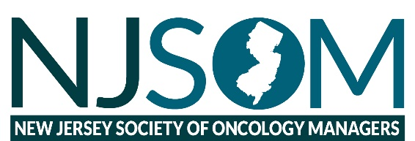
August 17, 2022
Dear Corporate Member:
The New Jersey Society of Oncology Managers would like to thank you for your continued interest and support in our association. During these times of uncertainty, NJSOM will continue to provide educational content to our members and continue to support our corporate members through meetings, programs, and mailings. We have always valued your support for our practices, but even more so now during the last 18 months.
NJSOM is a non-profit corporation 501C (6). Our corporate membership is based on a calendar year, January 1, 2022, through December 31, 2022. Our membership represents approximately 25 practices throughout New Jersey and Pennsylvania. NJSOM is recognized as a leader in education throughout the state. The membership is an annual partnership offering very specific benefits that include:
• Ability to disseminate information to our membership and networking
• E-mail access to membership, product updates and new product launch
Fall Conference: The Oceans Atlantic City NJ October 6th & 7th
As a member of NJSOM, you will gain access to a vast network of oncology professionals who strive daily to efficiently provide quality cancer care. Our educational topics include payer related information, legislative updates, staffing, human resources, coding/billing and clinical updates.
If your company requires an online grant application be completed for annual membership participation, please e-mail application process and directions to info@njsom.org or dj@njcancercare.com.
Booth Only: $2,000 per conference
● One attendee per conference
Non–member day meeting fee: $250.00 (meals included)
Please complete and return the NJSOM Corporate Intention Form found at the bottom. If you have any questions, please e-mail us at info@njsom.org.
Corporate sponsors are responsible to submit the following information:
Note: NJSOM will not cut and paste information without approval from corporate sponsors.
• Company Name
• Logo Requirement:
- j-peg or png
- 400 x 200
- white background
- horizontal
• Direct website link:
We appreciate your support and look forward to working with you at our upcoming meetings.
Sincerely,
Denise L. Johnstone
Treasurer
2022 Industry Partner Intention (please print clearly)
Please Mark the sponsorship level for 2022.
Booth Only ($2000.00) includes exhibit table and 1 attendee.
Additional attendees $250.00 per person/per meeting
If your company requires submission of an online grant, please contact Denise Johnstone via e-mail at dj@njcancercare.com
Name of Individual Submitting Paperwork: _______________________________________________
This individual will be our main contact and the person responsible for completing the registration form for each conference. E-mails will be sent out reminding you of the process.
Main Contact:
____________________________________________________
____________________________________________________
____________________________________________________

